Graphics

📘 Definition:
# Source: AI Source: Provided by: [Data Path: Persons Table -> ID Column: 1, Name_En Column: Motasem Essam] -> From: [ChatGPT] on [5/2/2026]
Graphics (often called computer graphics) refers to the creation, manipulation, and display of visual content using computers. It’s all about how images, animations, and visual effects are generated and shown on screens.

🎨 What do “graphics” include?
# Source: AI Source: Provided by: [Data Path: Persons Table -> ID Column: 1, Name_En Column: Motasem Essam] -> From: [ChatGPT] on [5/2/2026]
Graphics can be:
- Images – photos, drawings, icons
- Animations – moving visuals (like cartoons)
- 3D models – objects that look real and have depth
- User interfaces (UI) – buttons, menus, and layouts you interact with

🧠 Simple Example
# Source: AI Source: Provided by: [Data Path: Persons Table -> ID Column: 1, Name_En Column: Motasem Essam] -> From: [ChatGPT] on [5/2/2026]
When you play a video game like Minecraft or watch a movie like Avatar, graphics are responsible for:
- The characters you see
- The environments and worlds
- The lighting, shadows, and effects

🖥️ Types of Graphics

1. 2D Graphics (Flat images)
# Source: AI Source: Provided by: [Data Path: Persons Table -> ID Column: 1, Name_En Column: Motasem Essam] -> From: [ChatGPT] on [5/2/2026]

- Used in logos, drawings, and simple games
- No depth (just height and width)

2. 3D Graphics (Realistic visuals)
# Source: AI Source: Provided by: [Data Path: Persons Table -> ID Column: 1, Name_En Column: Motasem Essam] -> From: [ChatGPT] on [5/2/2026]
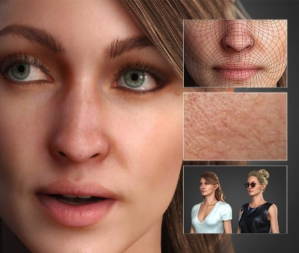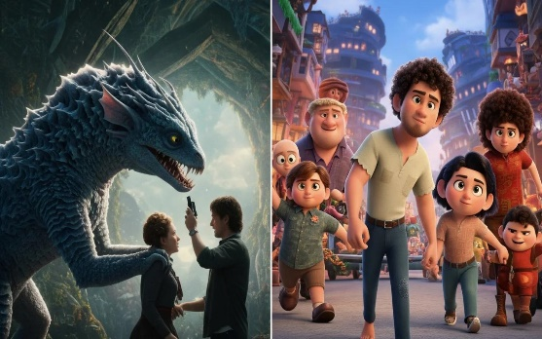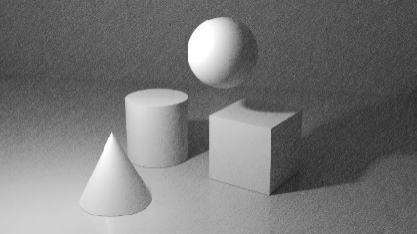
- Used in movies, advanced games, simulations
- Includes depth (looks more realistic)

⚙️ How does it work?
# Source: AI Source: Provided by: [Data Path: Persons Table -> ID Column: 1, Name_En Column: Motasem Essam] -> From: [ChatGPT] on [5/2/2026]
Computer graphics use:
- Mathematics – to calculate shapes, movement, and lighting
- Software – like design tools and game engines
- Hardware – especially the GPU (graphics card)

🚀 In short:
# Source: AI Source: Provided by: [Data Path: Persons Table -> ID Column: 1, Name_En Column: Motasem Essam] -> From: [ChatGPT] on [5/2/2026]
Graphics = everything visual you see created by a computer.

